The Asian School, Dehradun.
Holiday Homework 2024-25
Class LKG

Summer is messy, Summer is fun.
Trips to the beach, In the hot, hot sun.
Let’s give summer, A big fat cheer!
Summer is the best time of the year.

Dear parent,
It’s a vacation time again, a time to relax as well as to fruitfully occupy the children and keep their energies well directed. We seek you to lend your support and motivate your child. We have planned some activities to keep the children positively engaged on the principle of “learning by doing” by his/ her holistic development.
Kindly ensure that the Holiday Homework is completed by the students under the guidance of the parents.
So here we start….
- MORNING BLESSINGS
-Help your child inculcate good habits like doing “Surya Namaskar” or Yoga Asana and encourage him/ her to wish elders in the morning.
LINK: https://youtu.be/qIGRZS-YMWo
-If possible, visit a religious place of your choice.
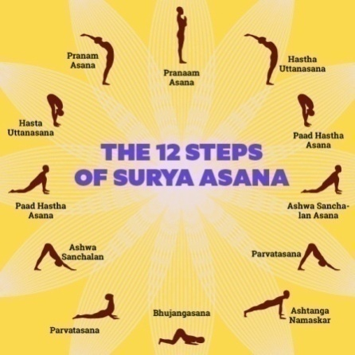

- LET'S RECITE SHLOKAS
Chanting of Shlokas can indirectly help in keeping the mind alert and sharpening the intellect.
Chanting Gayatri Mantra not only calms the mind but also fills our life with joy and happiness. The chant of the mantra starts with 'OM'.......It increases concentration and learning.
Link- https://youtube.com/watch?v=XS2cyf26rKw&feature=shared

- LANGUAGE DEVELOPMENT
-Object talk Activity- Talk to your child about any object from your surroundings every day. Let the child pronounce, observe, learn and speak out the name of the object.
-Encourage your child to converse in English
- My Table Mat - MY ART PIECE
Printing activities like vegetable printing have always been fun for children. Kids gets to experiment with color mixing, paint to be used and making patterns or prints. Compose a picture using fruit and vegetable prints. Children can use their own creativity and find innovative ways to create beautiful prints. You can make a table mat creatively using a chart paper and get it laminated. Bring it to school and it will stay in class so that you can use it during the lunch break.
Material Required
-Coloured Chart paper 18" ×12"inch
-Water Colour
-Crayons
-Vegetables
-Mirror, Star, Glitter for decoration

Enjoy this activity using these links:
- https://youtu.be/aBDubv-eyQk
- https://youtu.be/dLd2hg0N9rI
- https://youtu.be/2-2fSRR3B8E

- MY SPECIAL DAY WITH DAD
Father’s Day, 16th JUNE 2024.
“My dad is so special, he is strong and smart,
That is why I love him so, with all my little heart!! Happy Father’s Day!!”

Cooking without fire
Biscuit Canapes - A delicious and savoury small finger food with decorative topping. It is also a perfect ' Cooking without fire'.
Ingredients-
- One pack salted biscuit one onion , cucumber and tomato finely chopped .
- 1/4 spoon chat masala.
- 2 Spoon tomato sauce
- 1 cup full sev and grated cheese
Recipe-
- Mix the ingredients onion, tomato and cucumber in a bowl.
- Now add chat masala
- Line the biscuits on a plate .Take half tablespoon of tomato sauce and spread on biscuit.
- Now place a table spoon of mixture prepared on biscuits .
- Sprinkle some seva and create or spread cheese on top of biscuit.
- Biscuit canapes are ready
Link- https://youtu.be/7Lrb2KwRoqY?si=3vhijjpc-2dMeYdG

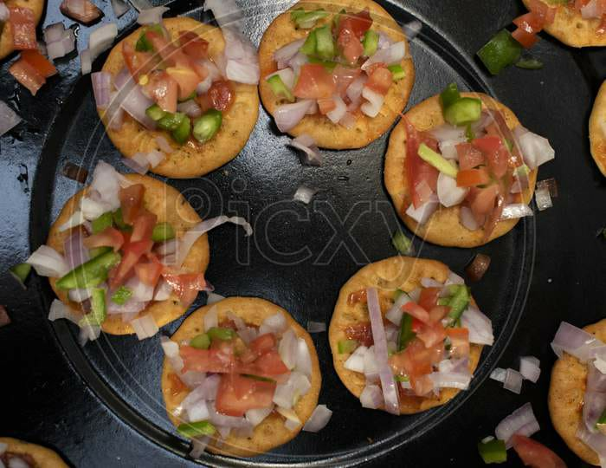

- Help your child to be Independent during the summer break and learn to:
- Button and unbutton the shirt.
- Laying the table
- Arrange their toy shelf
- Put on their socks and shoes.
- Eat lunch on their own.
- Keep their surroundings neat and tidy

- WRITING TIME

English
-Recognition and formation of alphabets (Aa to Ee) with their sound and associated words.
-Practice to write letters on the following pages 5,7,9,11,13 in ‘THE LITTLE HANDS’ (Small) alphabet workbook.
-Practice to write letters on the following pages 5,7,9,11,13 in ‘THE LITTLE HANDS’ (Capital) alphabet workbook.
-Learn the rhymes from the book ’THE LITTLE POET’ on the following pages 8,19.

Math
-Recognition and formation of numbers (1 to 10)
-Practice to write numbers on the following pages 7,9,11,13,15,16,21,23,25,27,29,30 in the ‘NUMBERS FOR JUNIORS’ workbook.

Hindi
-Recognition and formation of Swar with associated words.
-Practice to write Swar on the following pages 6,7 in the ’NANHI KALAM’ workbook.
-Brainy Activity Workbook- Do the following pages 5,6,11,23,34,46,49 in the ‘BRAINY ACTIVITY’ WORKBOOK’

- Submission of holiday homework will be on 15th JULY 2024

Thanks for your co-operation.

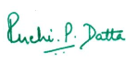

PRINCIPAL
