The Asian School, Dehradun
Holiday Homework 2024-25
Class PKG

Summer is messy, Summer is fun.
Trips to the beach, In the hot, hot sun.
Let’s give summer, A big fat cheer!
Summer is the best time of the year.
Dear parent,
It’s a vacation time again, a time to relax as well as to fruitfully occupy the children and keep their energies well directed. We seek you to lend your support and motivate your child. We have planned some activities to keep the children positively engaged on the principle of “learning by doing” by his/ her holistic development.

Kindly ensure that the Holiday Homework is completed by the students under the guidance of the parents.
So here we start….

- LET'S SAY A PRAYER
Prayer is not only just folding your hands , closing your eyes and speaking .Prayer is a much more meaningful part of life.. The importance of doing it before the kids start the day or eat a meal can teach them gratitude. Let's make our children learn the prayer and sing it.
Link - https://youtube.com/watch?v=Ju38Sdc2cSg&feature=shared

- EXERCISE TIME
Children needs to be active every day to promote their health growth & development. The benefits that children receive from being supported in regular physical activities builds strength and flexibility.

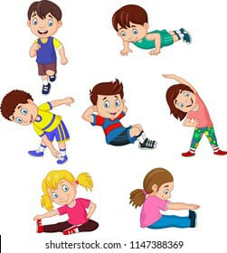

- MUSIC AND DANCE
Rhymes play an important role in the growth and development of children. It helps them to develop auditory skills, modulate voice and speech development. So, to enhance these skills and have fun with music, make your child listen to rhymes and also learn at least one rhyme.
Links for your reference is given below:
http://youtu.be/66SAHO2H-J0 , http://youtu.be/kK8FMTO-zks
http://youtu.be/JdGsFX9nhsQ , http://youtu.be/F6QOrTUtfDo

- LANGUAGE DEVELOPMENT
- Picture talk Activity
English for Beginner’s (Alphabet: I, T, L,)
Tell your child about the pictures and associated words that start with the letter. Let them pronounce the words, letters repeatedly so as to understand the sound of the alphabet.

- FINE MOTOR SKILLS- THREADING ACTIVITY
Threading is an excellent way to strengthen the finger muscle and learn to control the fingers as they work together also improves focus and concentration.

Method given below:
-Take an appropriate amount of pasta.
-Paint the pasta with the colour of your choice and allow to dry (available colours at home can be used).
-Cut an appropriate length of string or ribbon for a bracelet/ necklace.
-Take a piece of pasta onto one end with double knot so the other pieces don't fall.
-Thread the painted pasta onto the string or ribbon and then pull it through .
-Experience the joy of wearing a necklace or bracelet by you.

LINK- https://youtube.com/watch?v=K6NHupzsv2U&feature=shared
- https://youtube.com/watch?v=K6NHupzsv2U&feature=shared

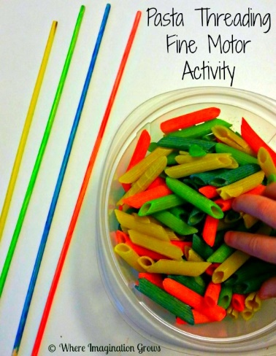

- MY SPECIAL DAY WITH DAD
Father’s Day, 16th JUNE 2024.
“My dad is so special, he is strong and smart,
That is why I love him so, with all my little heart!! Happy Father’s Day!!”

CARD MAKING ACTIVITY
Make a card on Father’s Day with the help of your mom and wish him on the day to make him feel special.

Link for reference is given - https://youtu.be/DAwrnKSGCdk?si=-jgc94aLmEpQ03Mf
(Material is attached for the given activity)

- WRITING TIME

Pre writing Skills (Pattern workbook)
-Practice the patterns given on the following pages 10 to 15.
-Learn the rhymes from the book ’THE LITTLE POET’ on the following pages 6,24.

NUMBERS
-Cherry Blossoms- Practice to write numbers given on the following pages 9,33,39,51.

ENGLISH
-Cherry Blossoms- Practice to write alphabet given on the following pages 35,41,61.

- Revise and complete the worksheet attached.
- Submission of holiday homework will be on 15th JULY 2024.

Thanks for your co-operation.

PRINCIPAL

